19.11: The type of process is not specified. We can use 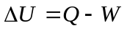because this applies to all processes.
is positive since heat goes into the gas; 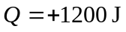
positive since gas expands; 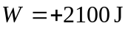
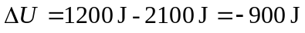
We can also use 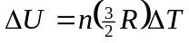 since this is true for any process for an ideal gas.

